**Local DNS Attack Lab**

**Karan Amrutesh**

**2.1 Configuring the DNS server:**

* The *named.conf.options* file:

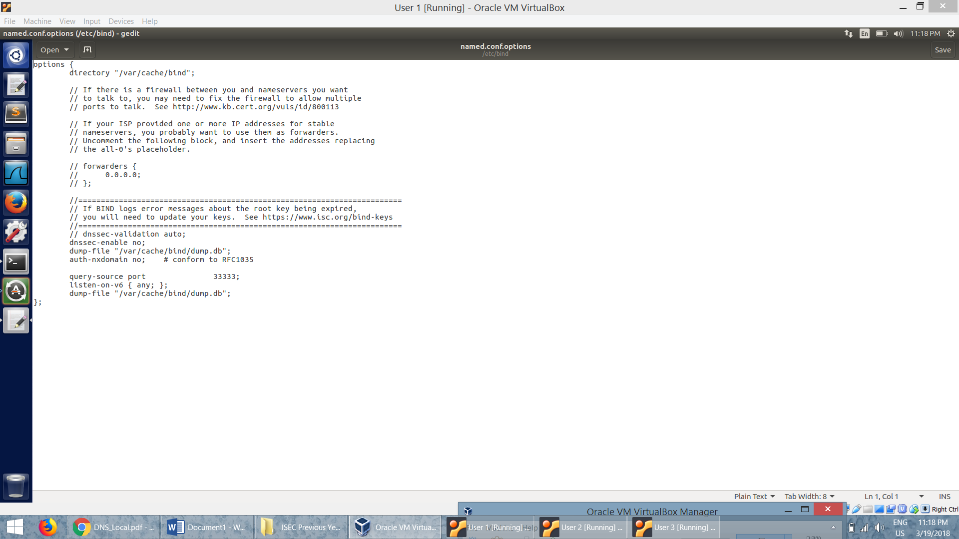

* */etc/bind/named.conf* file

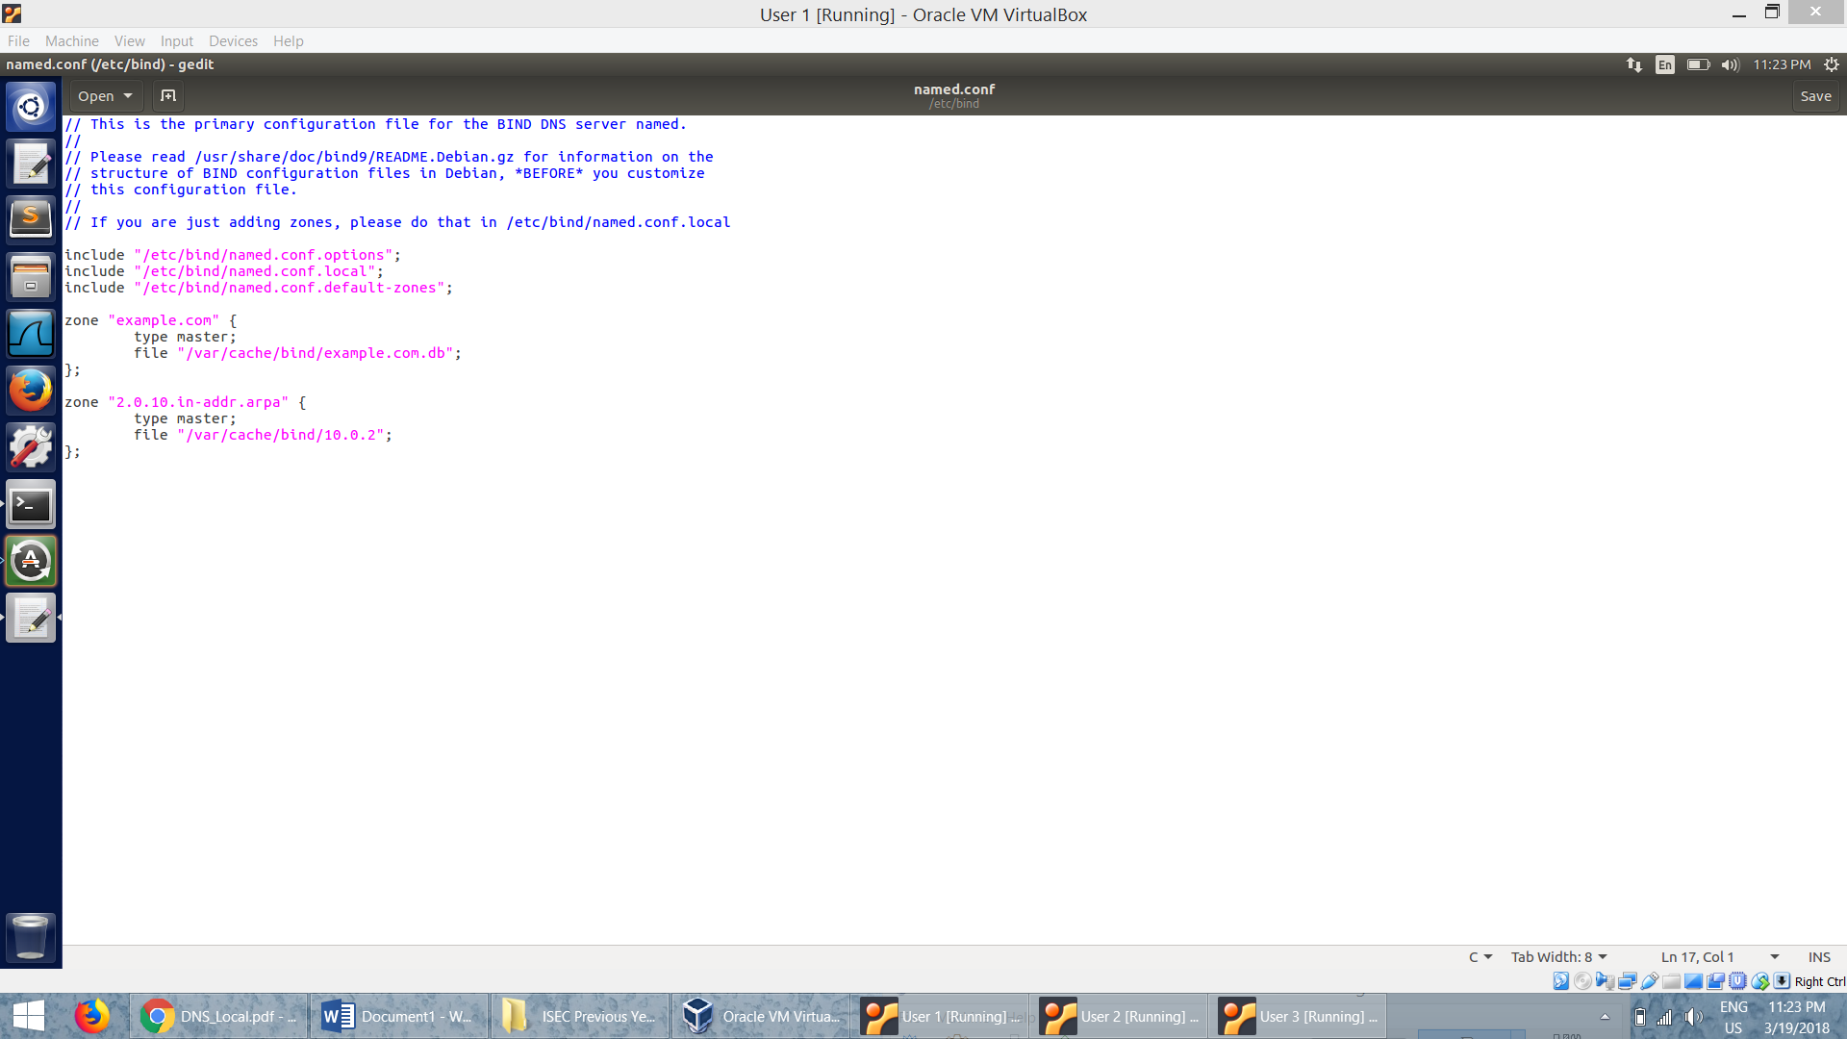

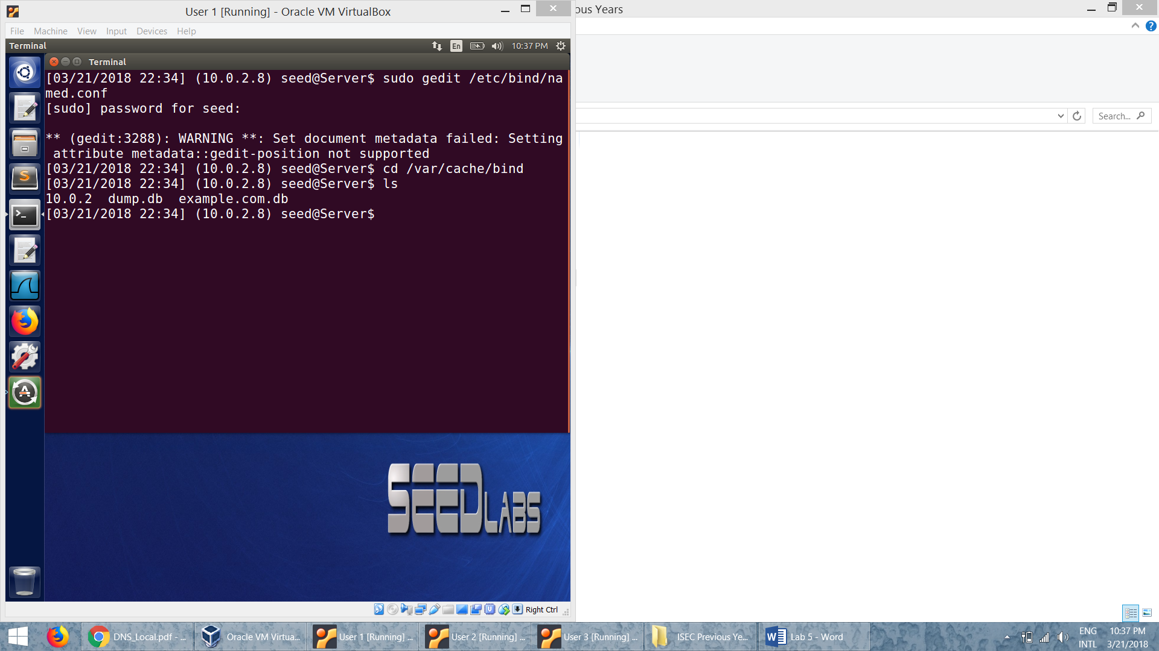

* Zone file for reverse lookup:

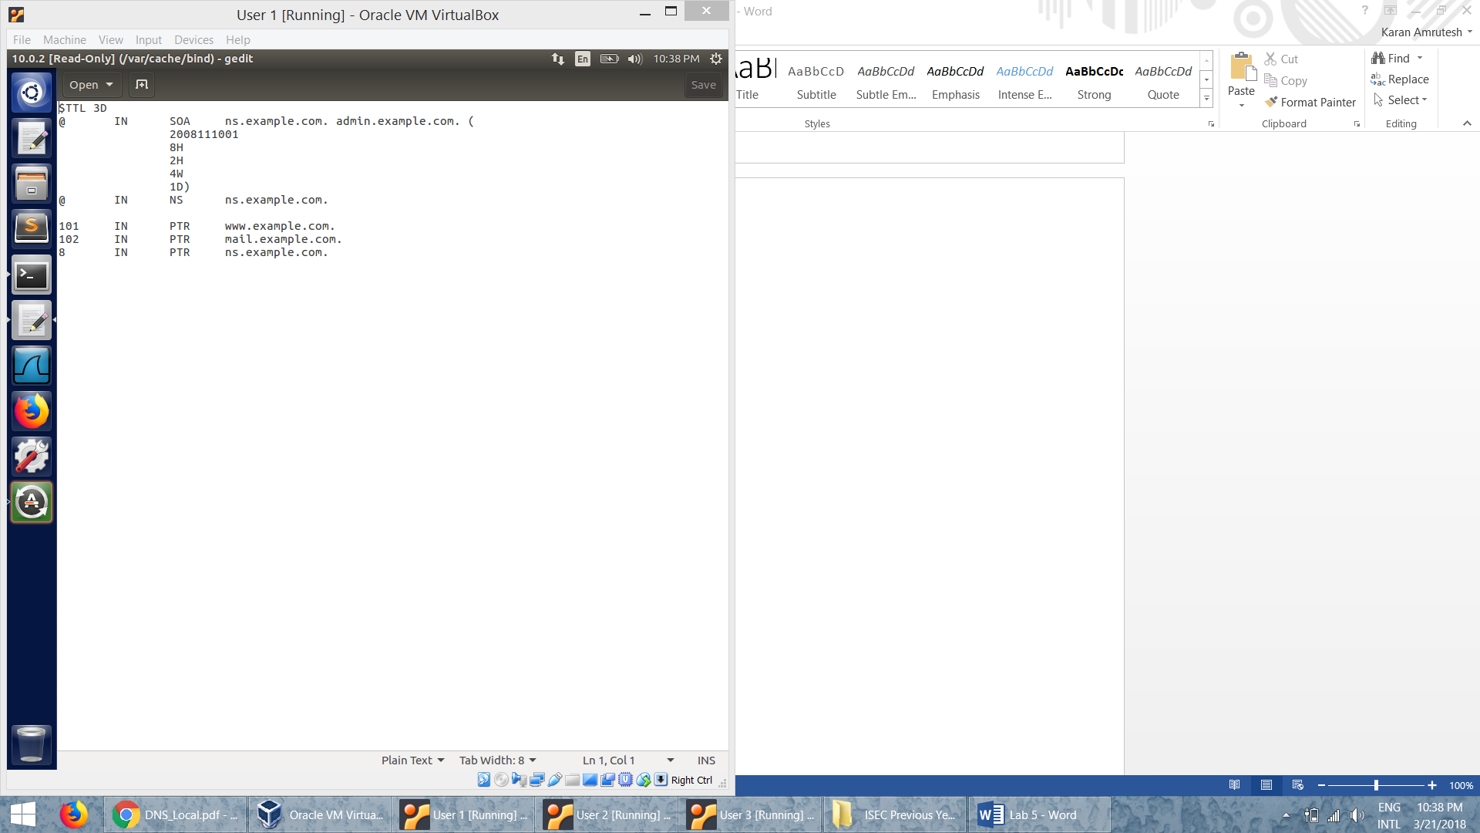

* Zone file for forward lookup:

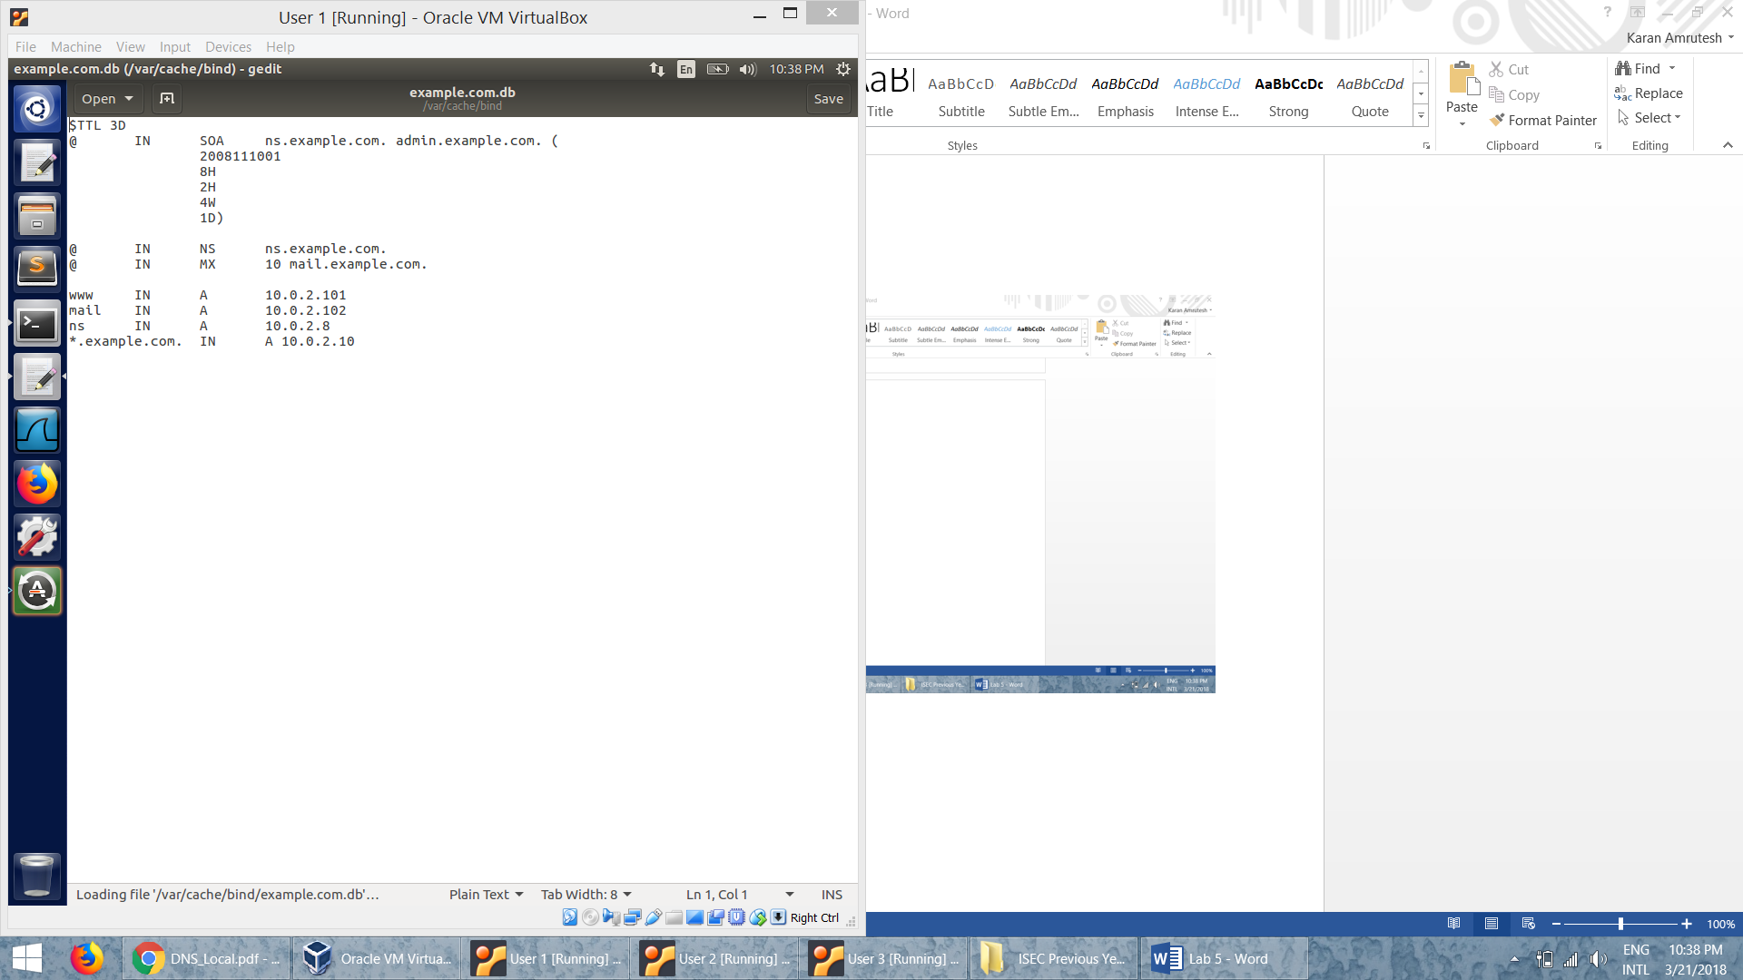

* Once the configurations are done in the server, we restart the DNS server:

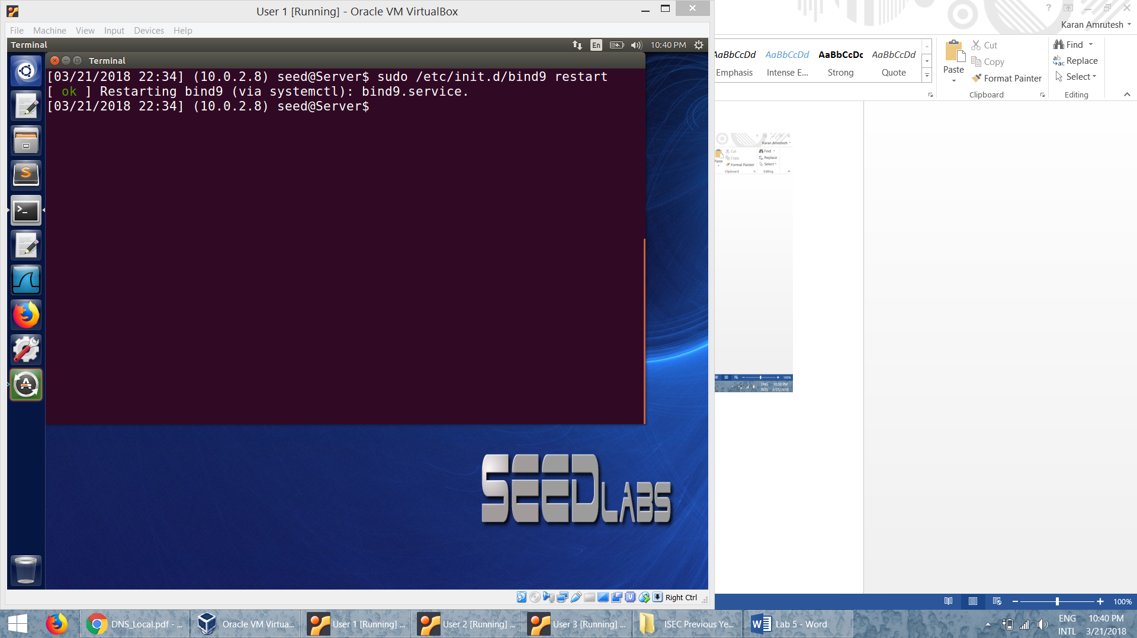

**2.2 Configure the User Machine:**

* */etc/resolv.conf* file:

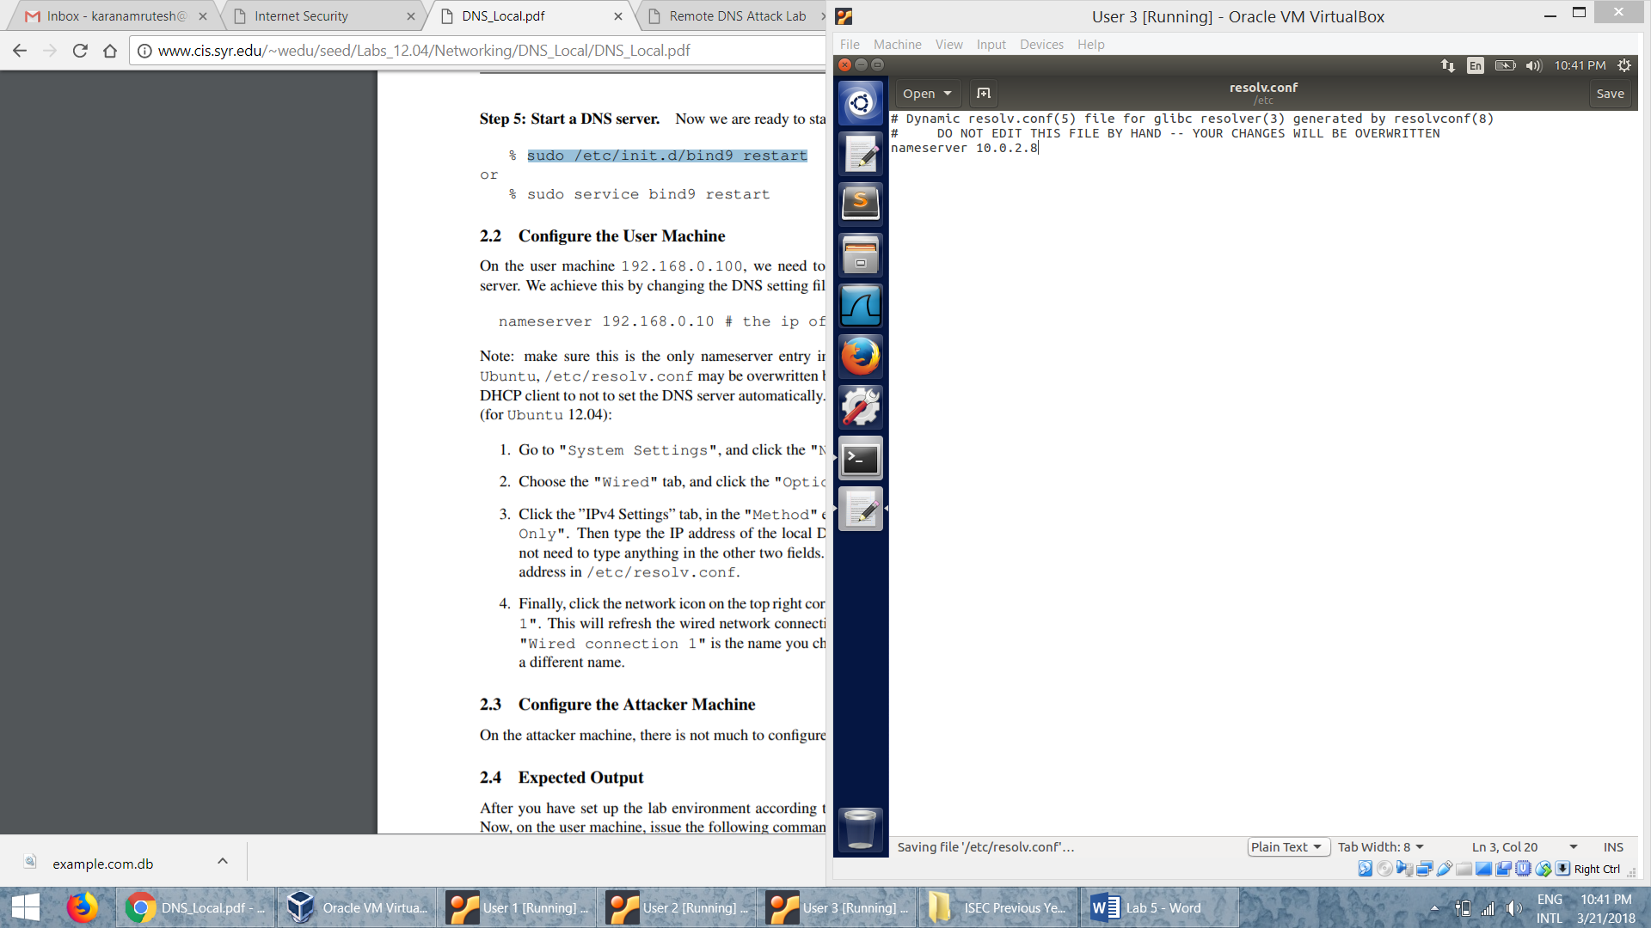

* Setting the server IP in network setting:

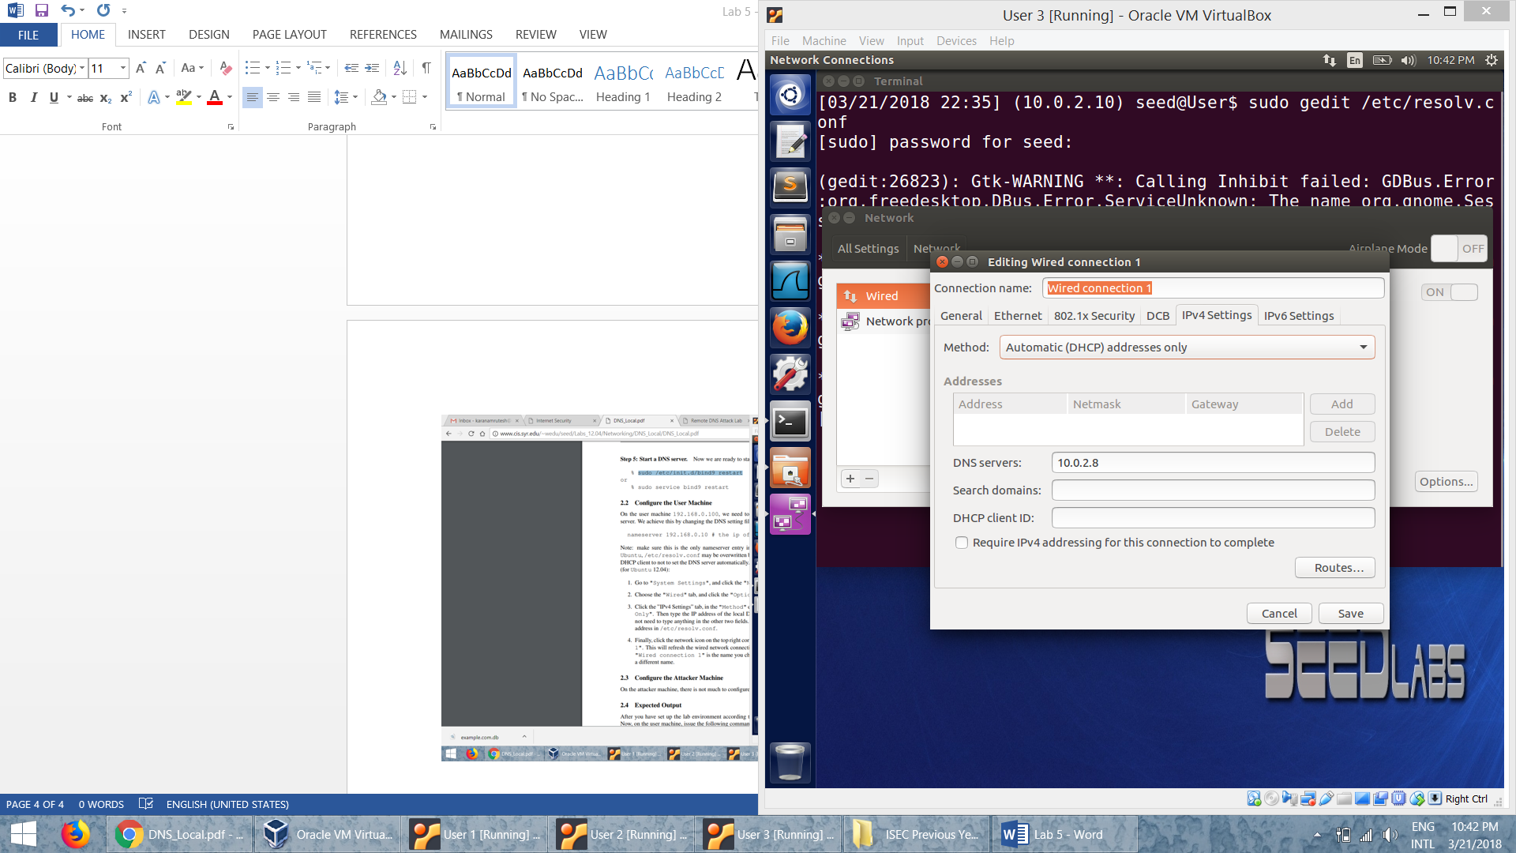

* Example dig for example.com:

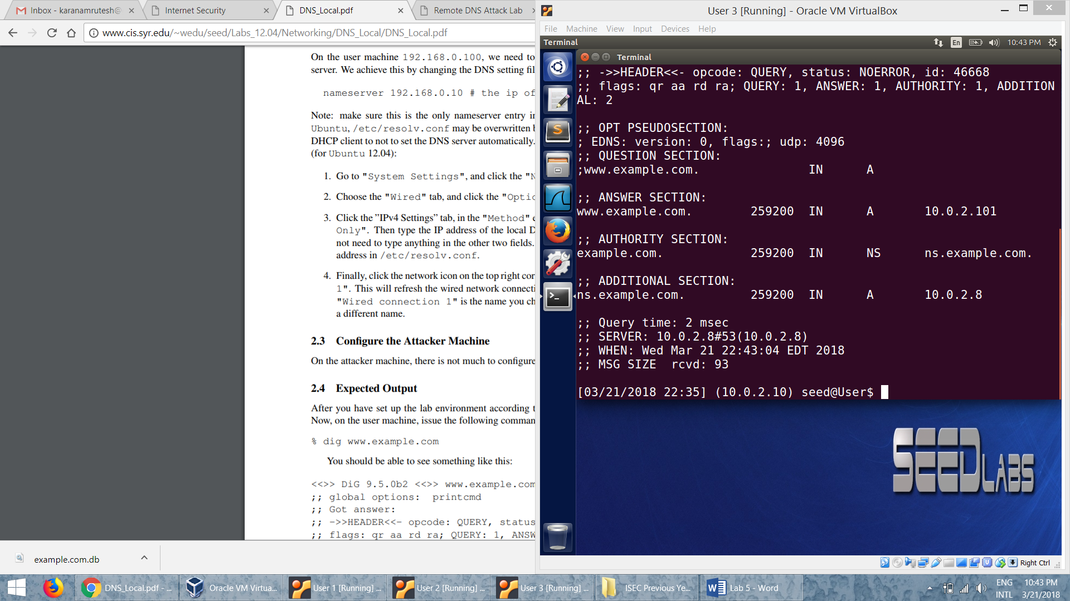

**Task 1: Attackers have already compromised the victim’s machine**

* We modify the */etc/hosts* file in the user machine and add an entry for example.com

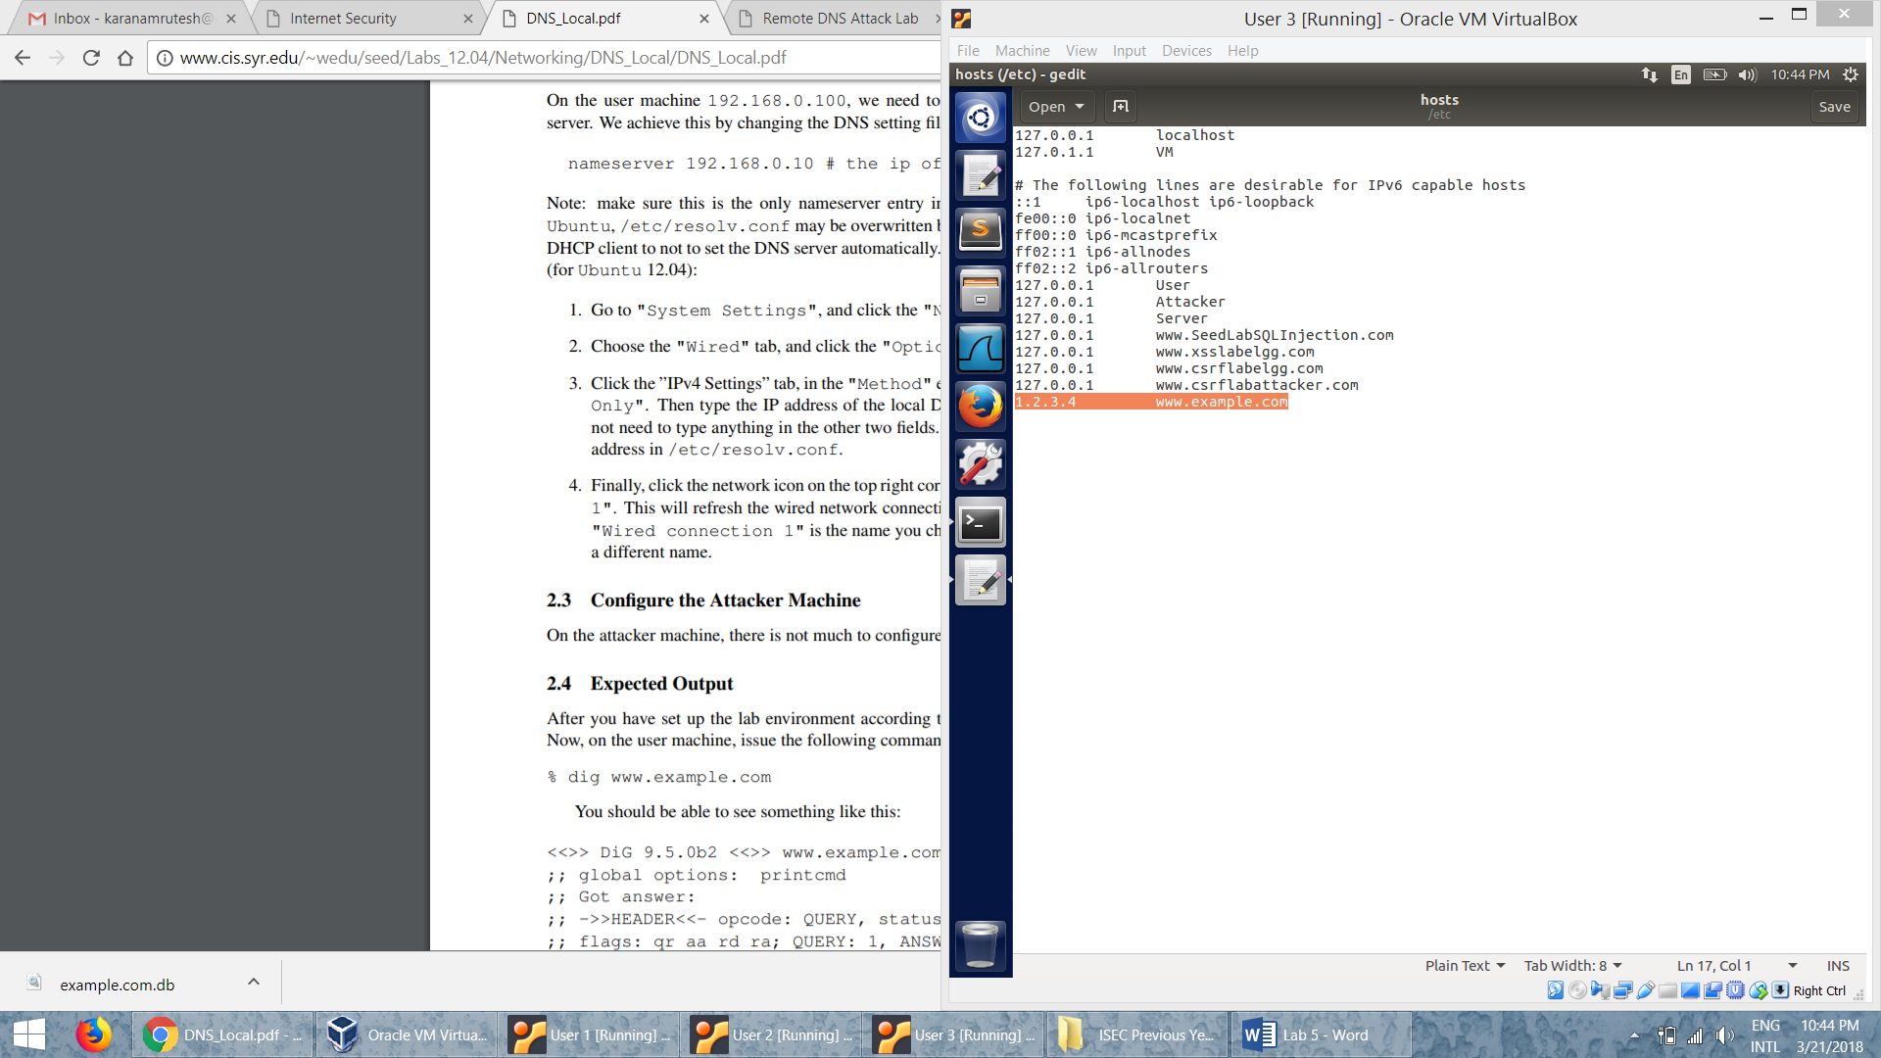

* After the attack, when we ping, it uses the ip address we assigned i.e., 1.2.3.4 as the ip address of example.com
* We assume that the user computer is compromised and the /etc/hosts file is modified. So now the attacker redirects the requests to www.example.com to a malicious ip 1.2.3.4.
* When we modify the /etc/hosts file, the attack is successful since this is the first place where the lookup happens. This takes preference over remote DNS lookups.

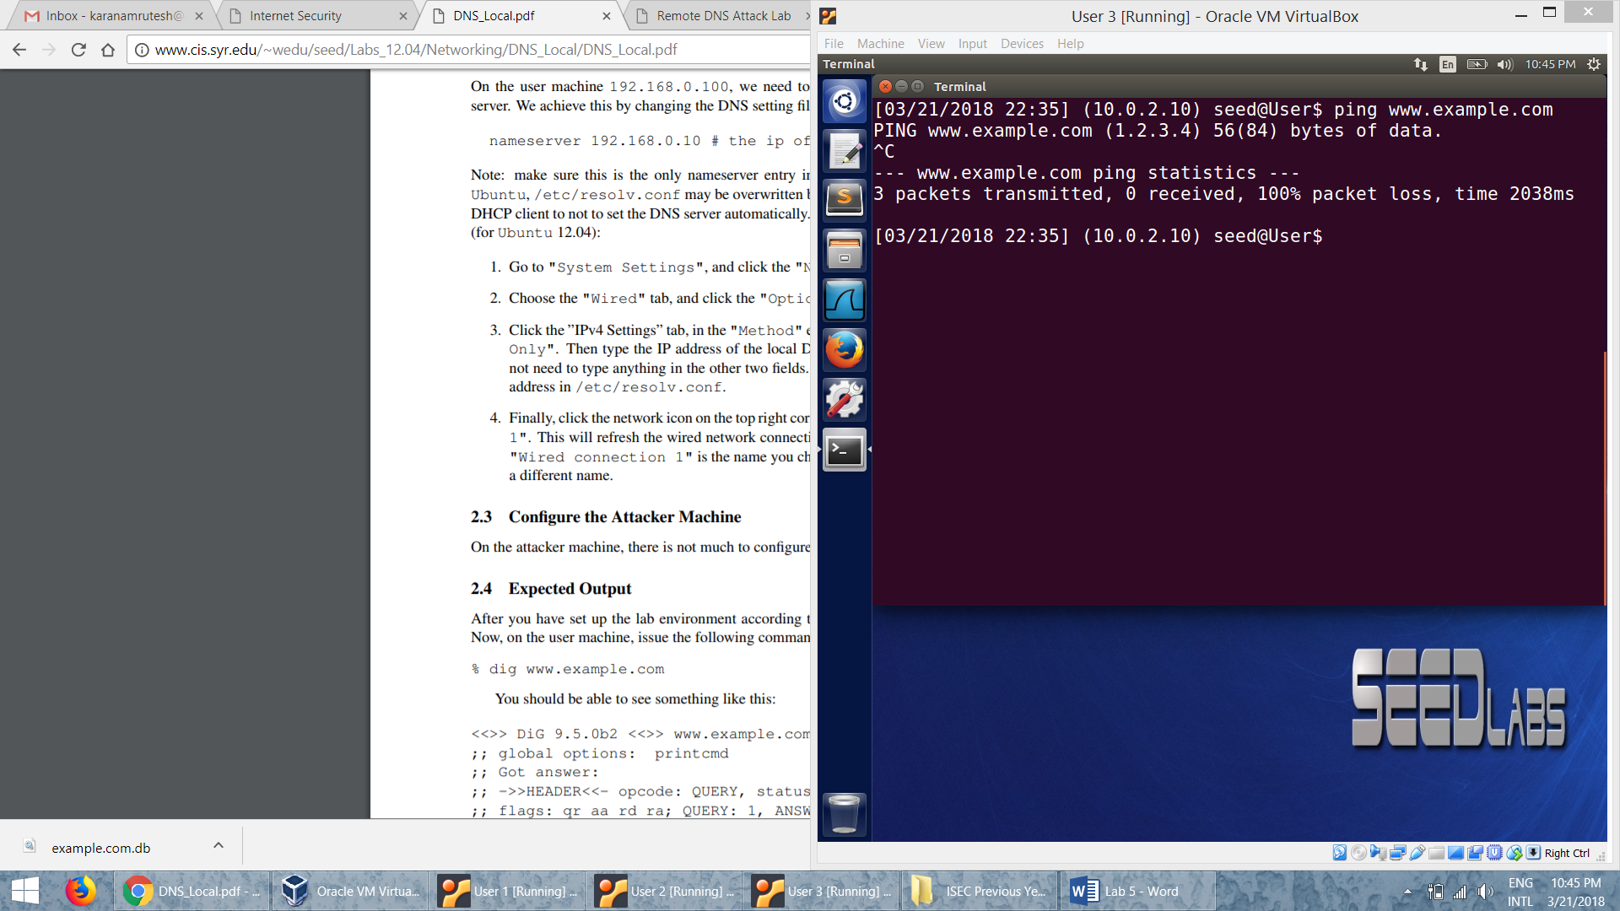

**Task 2: Directly Spoof Response to User**

* The attacker runs netwox tool to spoof the user with a reply from the DNS query.

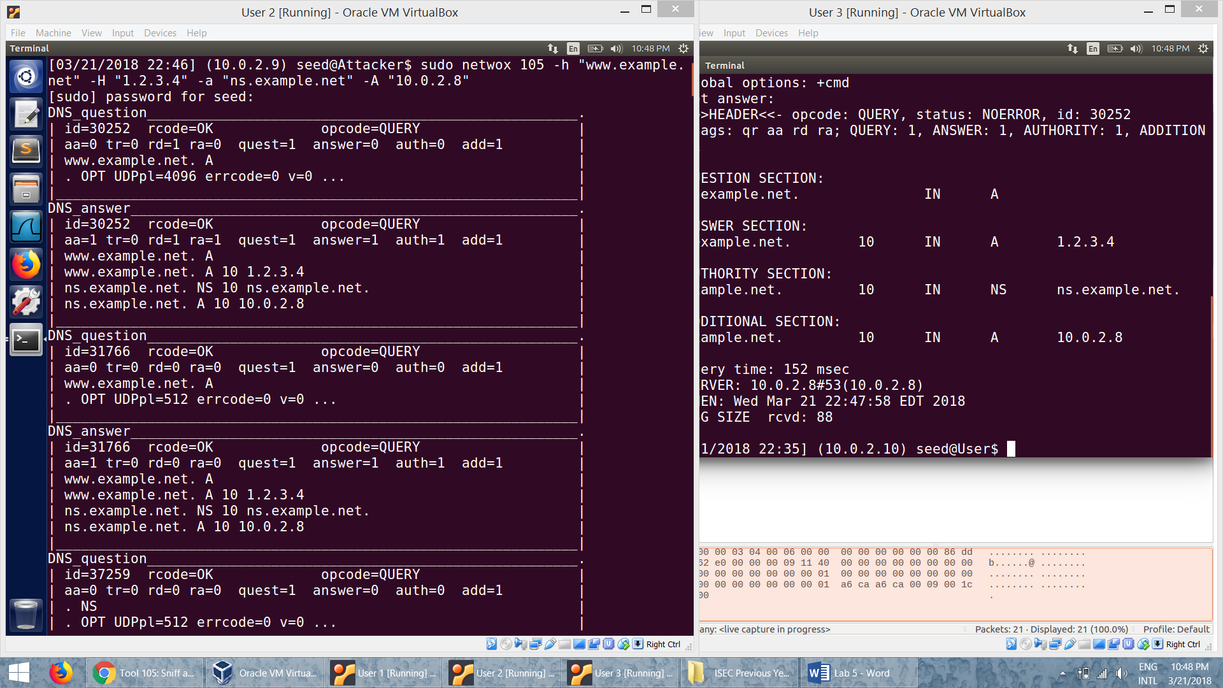

* The attack is successful since we see that dig of example.com returns 1.2.3.4 which is actually spoofed by the attacker.

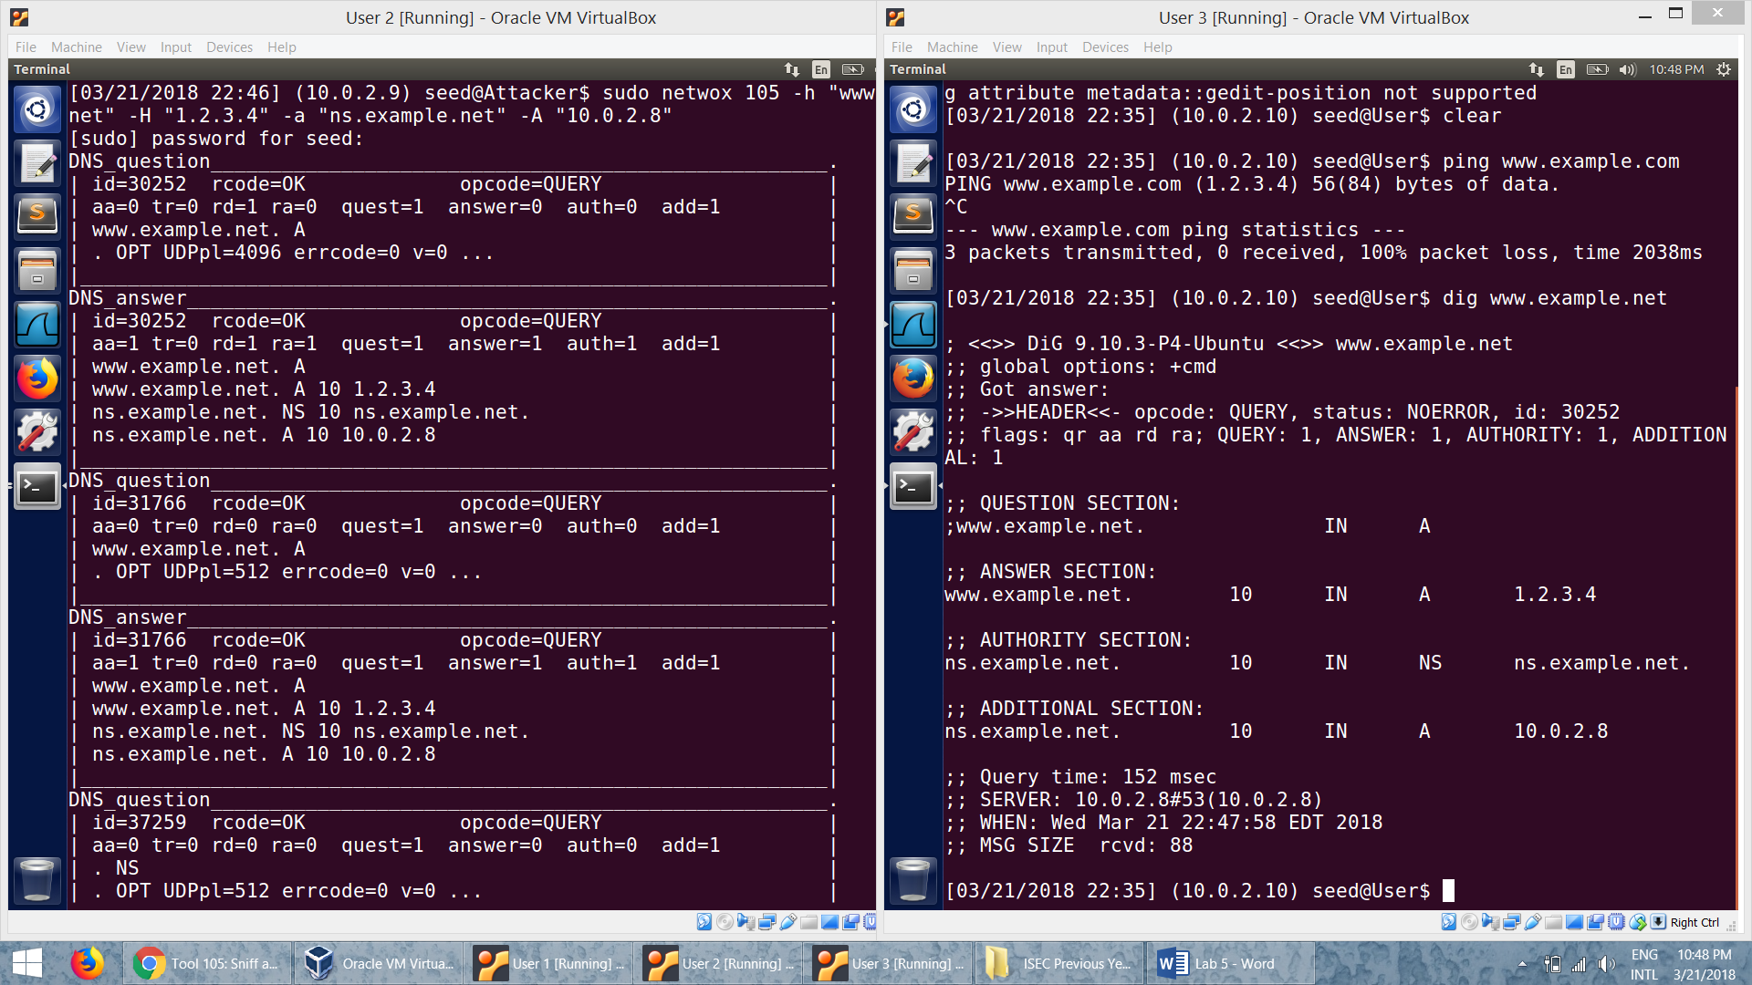

* Wireshark capture showing that the attack is successful:

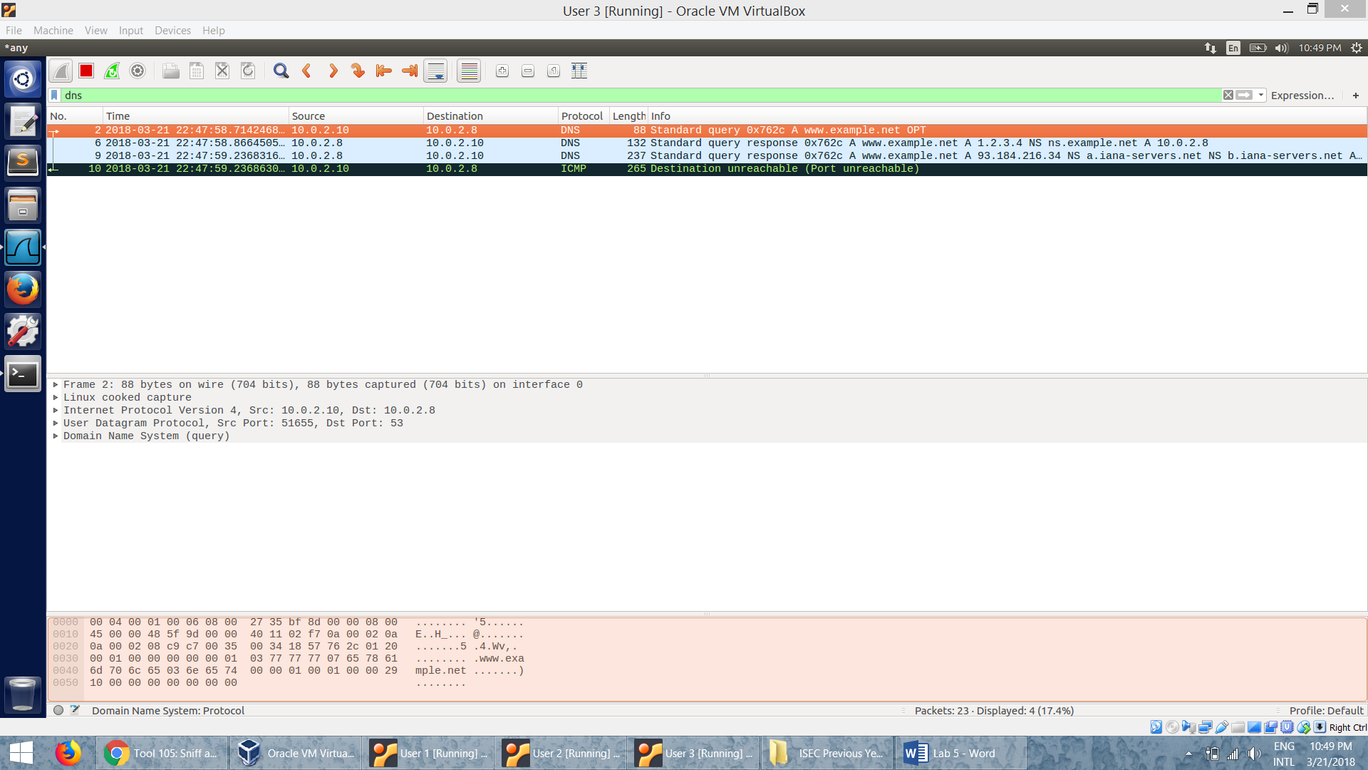

* When the attacker cannot attack the victim’s computer and if he is on the same network then he can spoof a reply to the DNS request sent by the user. He will send a malicious ip for the DNS query so that he redirects the user to the malicious IP.

**Task 3: DNS Server Cache Poisoning**

* dig before the attack:

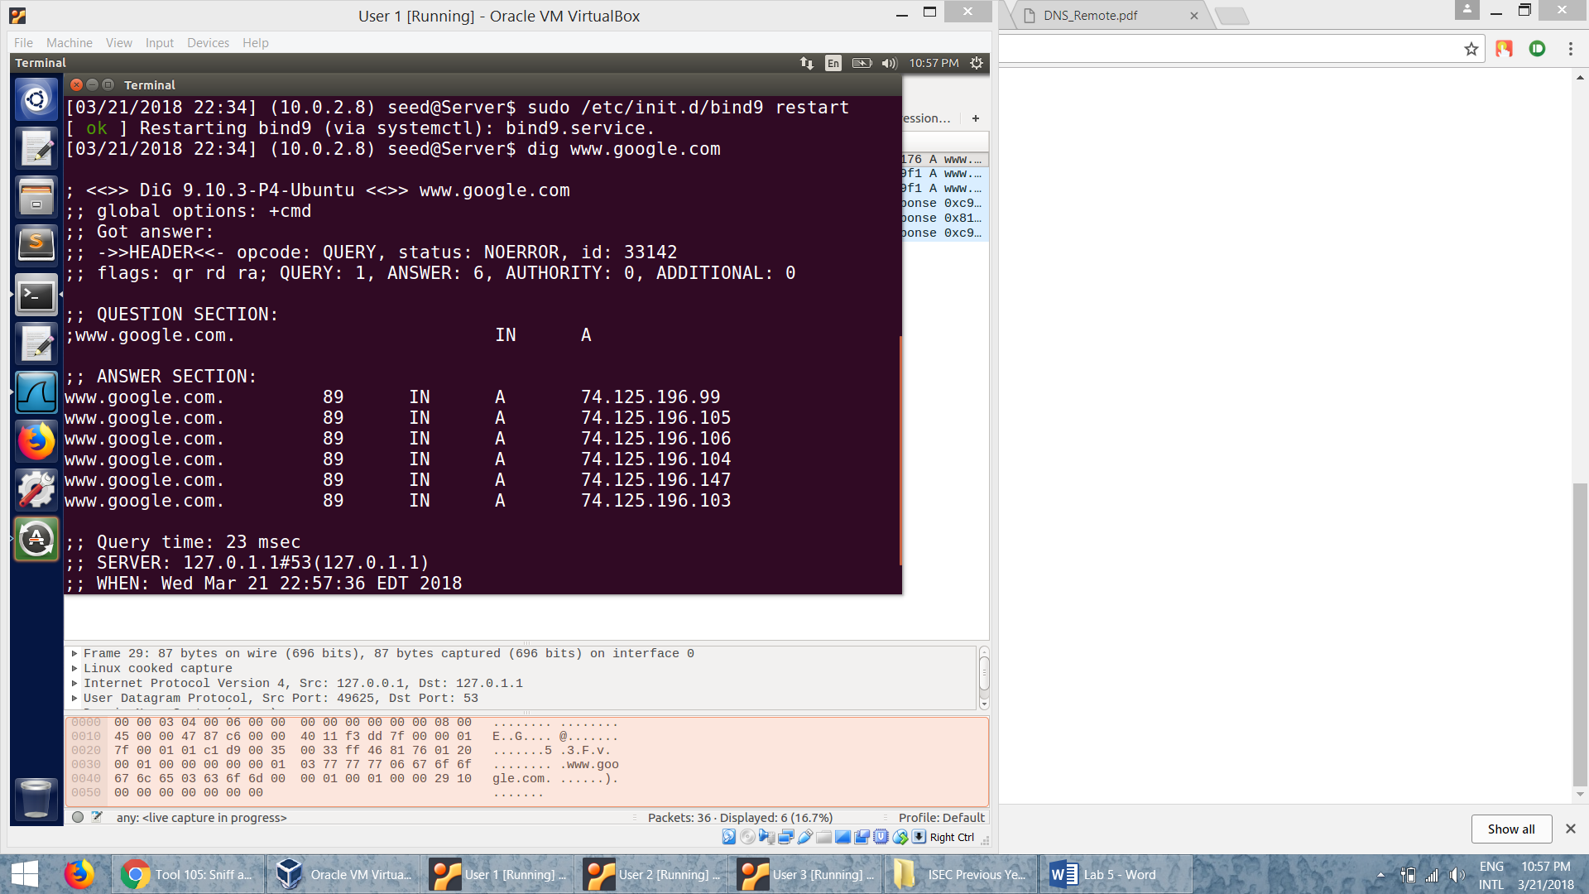

* flush the cache, then the attack is initiated using the netwox command similar to the previous task:

*sudo netwox 105 –h “www.google.com” –H “1.2.3.4” –a “ns.google.com” –A “10.0.2.8” –f “src host 10.0.2.8” –T 600 –s “raw”*

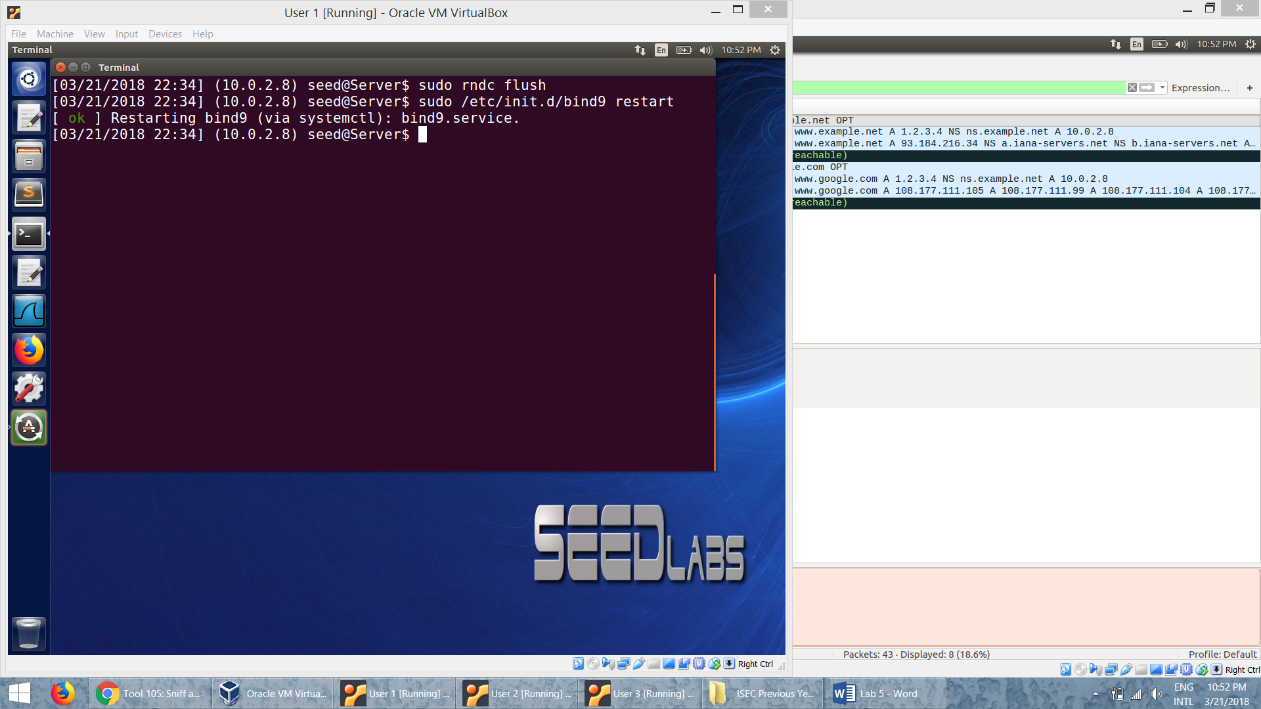

* The dig after the attack:

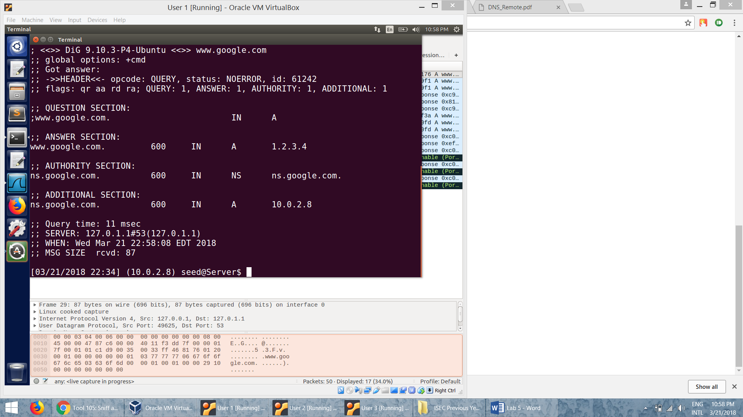

* The wireshark capture showing that the attack is successful

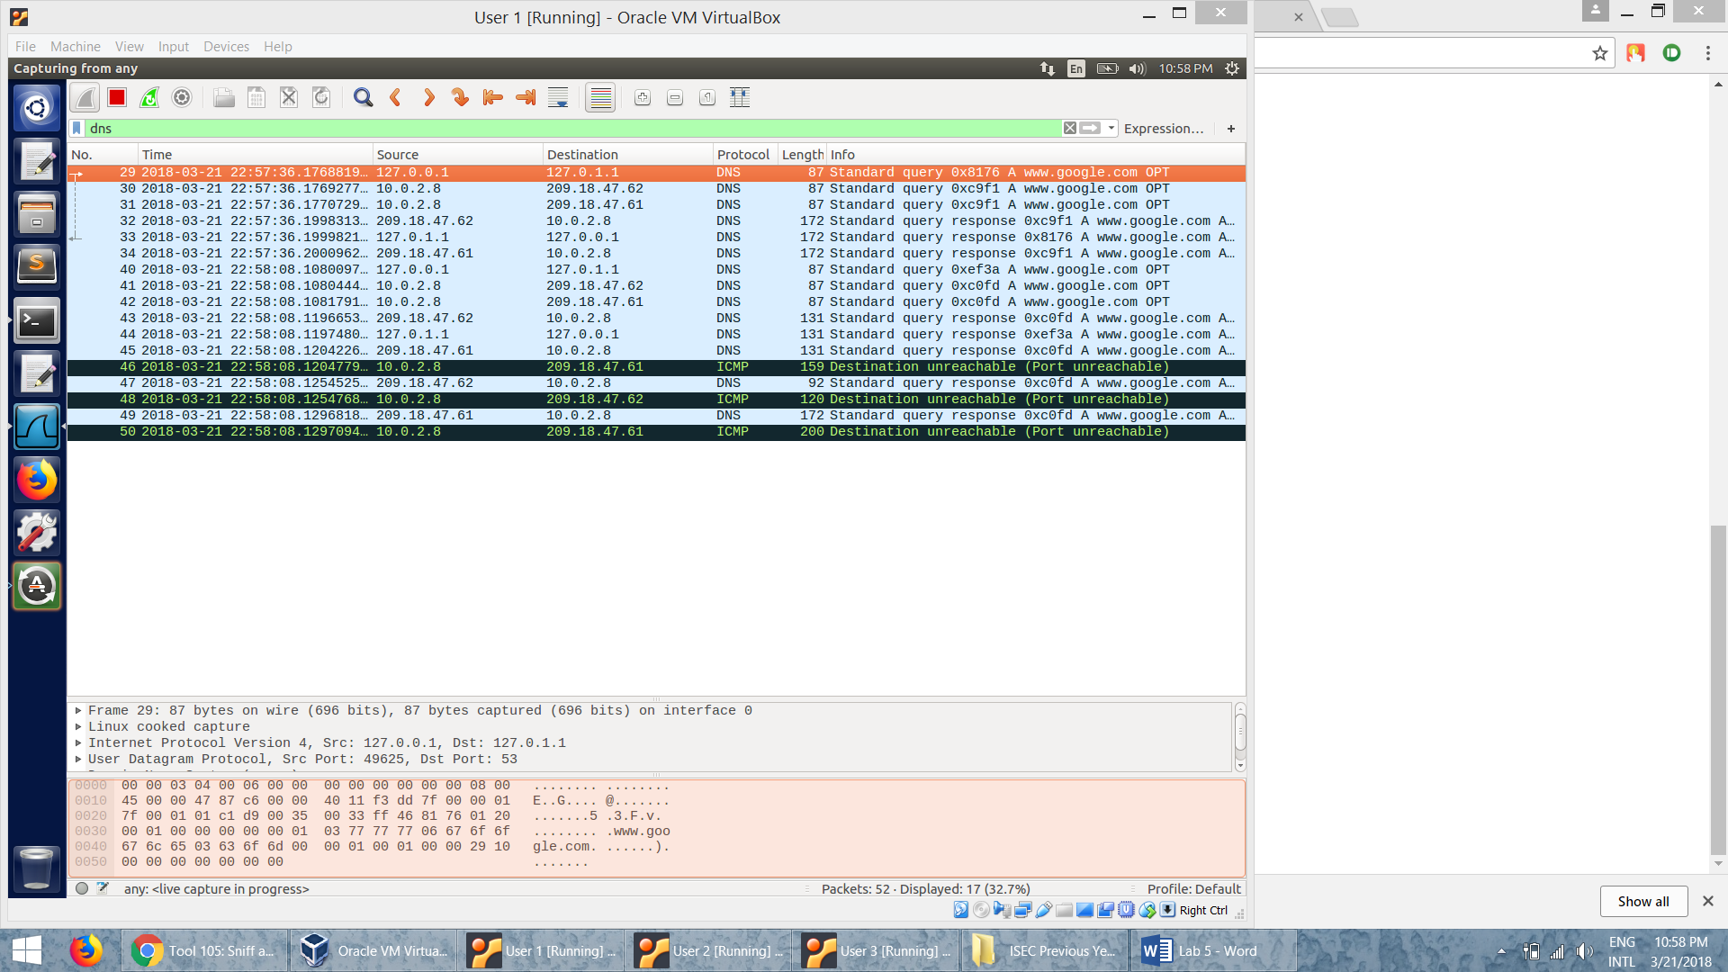

* Here we are spoofing the DNS server response instead of the local host response like in the previous case. The attacker uses netwox tool to spoof a response to the query sent by the DNS server to the other DNS servers since it could not resolve the query by itself.
* Here we are trying to poison the cache of the server, so the attack is more dangerous and long lasting, the attack affects all the systems that access this DNS server to resolve the request for [www.google.com](http://www.google.com).
* In the previous case, it affected only the host system. Until the cache is cleared, the attack lasts and the request will be directed to a malicious ip.